DAV PUBLIC SCHOOL ,NAGINA MARG HANUMANGARH
Summer Vacation Homework: 2018-19
Class-2nd
Request to Parents:-
1.Encourage your child to do the work himself/herself.
2.The home assignment must be submitted on 15th -16th June
ENGLISH
“Education is the passport to the future, for tomorrow belongs to those who prepare for it today”
Q.1. Learn lesson “Puss and the Parrot”, ‘The Helpful Friends, A Spark in the Dark (Meaning words with sentences and Q/Ans)
Q.2.` Write 10 words each from sound words of ‘ar’ (page 17), ‘ai’ (Page-22), ‘ou’ (page-28) from english reader book.
Q.3. Learn by heart poem ‘Little Pussy’
Q.4. Learn two forms of verbs (1 to 20) and write one time in note book.
Q.5. Learn simple present tense and make your own ten sentences. (Example : I eat mango, I go to school)
COMPLETE THE WORK SHEET
Q1. Put ‘a’ or ‘an’ before the given picture.
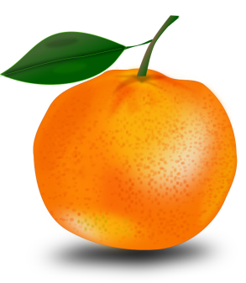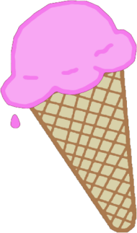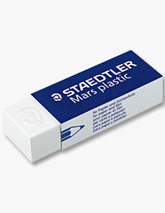
______ ________ _______ ________ __________

Q2. Write five naming words/ nouns and pronouns inside the apples.
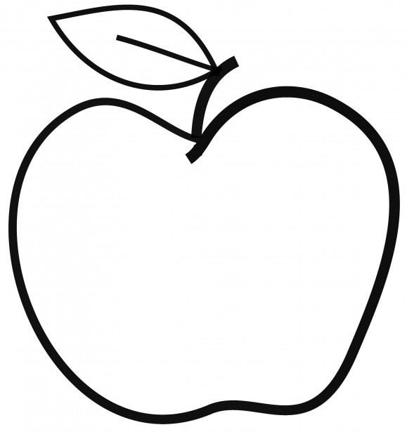

Noun Pronoun
Q.3 Put the correct prepositions (on, into, near, under)
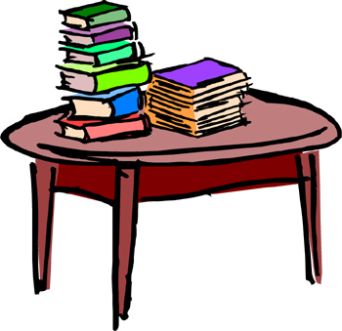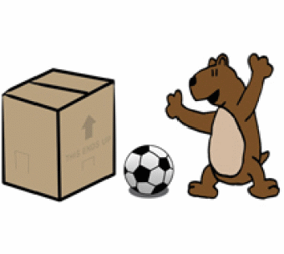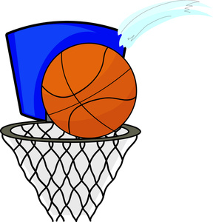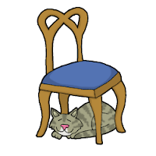
_________ _________ __________ ___________
Maths

- Do ten sum of add
- Do ten sum of subtraction
- Write table 2 to 15
- Numbers name 1 to 100
- Do addition practice by drawing abacus in NB from page no. 27
- Write the numerals for the following
- Five hundred and thirty seven
- Eight hundred twenty two
- Five hundred ten
- Three hundred
- Do word problem question from page no. 31.
- Put the sign
- 142 ( ) 136
- 152 ( ) 195
- 121 ( ) 121
- 46 ( ) 37
- 98 ( ) 100
- 566 ( ) 600
Science
- More about me
This is me

My name is ………………….. I am a……………………. I am ……………years old.
I am in class…………….. I study in ……………….school.
My address is……………………………….……………………………………………………. My contact no is…………………………..
- Write five things that you can do yourself.
1……………………………………………………………….. 2………………………………………………………………..
3……………………………………………………………….. 4………………………………………………………………..
5…………………………………………………………………
- Classify the foods given below into the correct column.
Channa dal | rice | spinach | mango | orange | ghee
kulfi | wheat | cabbage | fish | meat | Rajma

- Food from plants
Grains | Pulses | fruits | Vegetables

- Food from animals
Milk products | Food from animals
- Write the names of any five food items which we make from milk.
1………………….. 2……………………….. 3……………………… 4……………………… 5…………………….
- Activity-Collect the wrappers and advertisement of toothpaste, toothbrush,dettol,hair oil,shampoo etc.Make a collage by using a chart.

- My favourite-
- Food is…………. Colour is………….. Toy is…………….. Game is…………

Drawing
- Make three pictures by using shapes.
- Make a tree with thumb impression.

Hindi
- अपनी पाठयपुस्तक के किन्ही तीन पाठो का सुलेख लिखो l
- चार दिन के समाचार पत्र से दस दस कठिन शब्द छांट कर लिखिए
- अपने कमरे की उन वस्तुओं के नाम लिखे जो आ ओ की मात्रा वाले हो
- अपनी दादी नानी के जन्मदिन का ग्रीटिंग कार्ड बनाइये
- अखबार की कतरनो से हिंदी वर्णमाला के कोई वर्णों के आकार काटकर5
पुस्तिका में चिपकाये l

- स्वयं के विषय पर 10 पंक्तिया लिखे l

