DAV PUBLIC SCHOOL ,NAGINA MARG HANUMANGARH
Summer Vacation Homework: 2018-19
Class-1st

Request to Parents:-
1.Encourage your child to do the work himself/herself.
2.The home assignment must be submitted on 15th -16th June.
3. Use separate notebook for your holiday assignment.

Subject-English

Q1. Paste or draw the picture of a pencil and write 5 line on it.
Q2. Write 5-5 words using vowels (a,e,i,o,u) (Ex- Him, Fox).
Q3. Write 10-10 words of ee and ll sounds.
Q4. Draw a cake, colour it , write your name and birth date on it.
Q5. Read lesson 1-5.
Q6. Paste or draw the picture and frame 8 sentences using this and that.

Subject-Maths

Q1. Do 8 sums of add and 8 of substraction.
Q2. Write counting 101-300.(one time)
Q3. Write and learn table 2 to 10.(one time)
Q4. Paste different cuttings of colorful paper having the shape of circle, square , rectangle and triangle
Q5. Write numbers name 1-30 (one
time).
Q6. Draw a vehicle using all shapes and color it.

Science
Q1. Draw or paste five things that you used to keep your body clean?
Q2. Write the sense organs and their function along with the picture.
Q3. Write ten names of healthy food items.
Q4. Write the names of your family members.
Q5. Write the name of five clothes that you wear in summer season and draw five eatables that you like most in this season.
Q6. Find out six body parts from the puzzle.
H | E | A | D | P | M | H | M | F | Q | N
A | K | E | Y | E | T | A | O | O | R | E
N | N | O | S | E | N | I | U | O | O | C
D | A | L | O | P | Q | R | T | T | S | K
R | R | F | A | R | T | O | N | G | U | E
O | M | G | N | E | C | K | G | P | U | N
S | H | O | U | L | D | E | R | O | A | T
- …………………..………
- …………………..………
- ………………….….……
- ………………….……….
- ………………….……….
- …………………………..

Hindi
1 Lkeku y; okys vk o b ek=k ds nl nl tksMs cukvksA
2 Lkekpkj i=ks ls fuEufy+f[kr ek=kvks ds nl nl “kCn fy[kks A
( k f h q w )
3 fp+=kss dks igpku dj muds Ukke fyf[k, 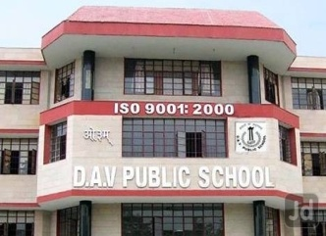 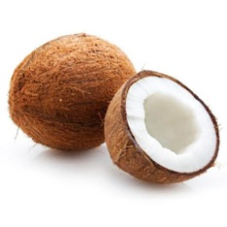 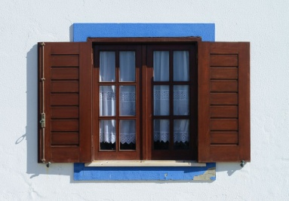 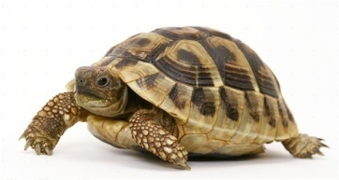 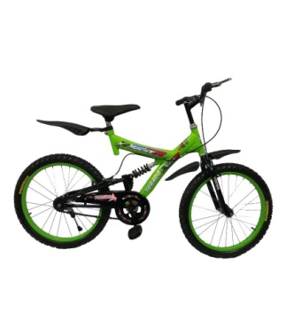 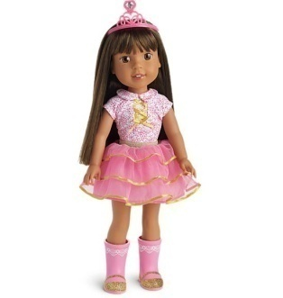 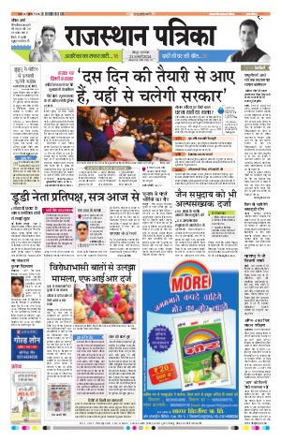 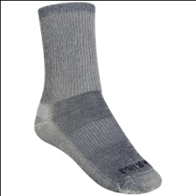 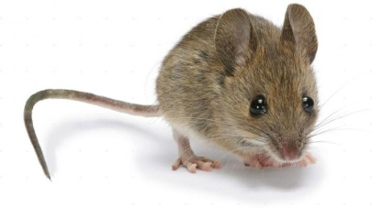

4fn, x, izR;sd vj ls nks&nks “kCn cukvks
xk
Ekk
jk
fl
fr
ph
ih
tq
iq
pw
Qw

